|  |
| --- |
| jg studio |
| Mario Get-Away |
| **[Assignment #2 – Unity Game** |
| Version #02  All work Copyright © 2016 by JG Studio.  All rights reserved. |
| **Jason Gunter** |
|  |

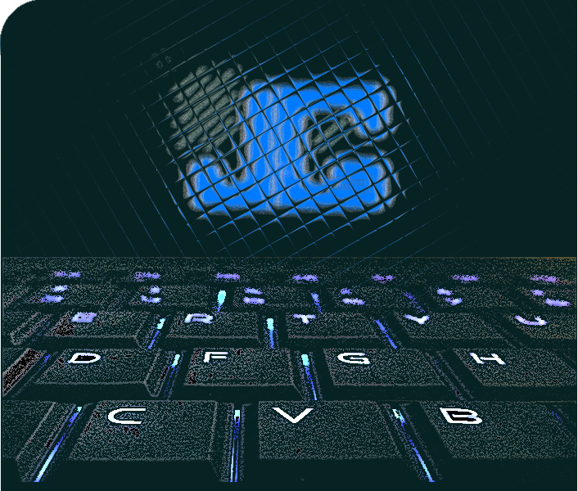

|  |
| --- |
| October 21st, 2016 |

**Table of Contents**

Contents

**Version History** 3

**I.** **Game Overview** 4

**II.** **Game Play Mechanics** 4

***III.*** **Camera** 4

**IV.** **Controls** 4

**V.** **Interface Sketch** 4

**VI.** **Menu and Screen Descriptions** 5

**VII.** **Game World** 6

**VIII.** **Levels** 6

**IX.** **Game Progression** 6

**X.** **Characters** 6

**XI.** **Enemies** 6

**XII.** **Items** 6

**XIII.** **Vehicles** 6

**XIV.** **Scripts** 6

***XV.*** **Scoring** 7

**XVI.** **Sound Index** 7

**XVII.** **Art / Multimedia Index** 7

**XVIII.** **Future Features** 7

# **Version History**

<https://github.com/jgunter7/MarioGetAway/commits/master>

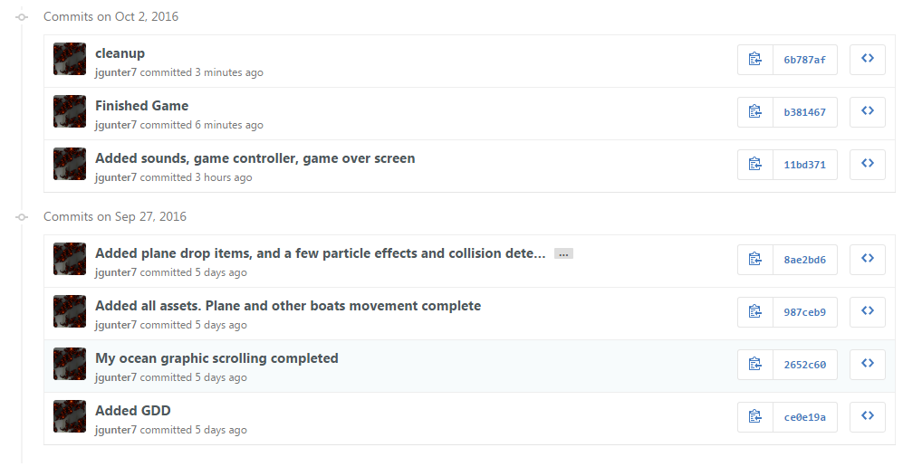

1. **Game Overview**

*Zombie takeover is a simple scrolling game, where the player must control an infected ship. The player can infect other ships, by sinking them to gain points. The air force can drop items into the game, such as bombs on buoys and supplies on buoys. The gas tank supplies will allow the zombie ship to continue to wreak havoc on the ocean. Hitting other ships gains points, but also decreases the condition of the ship. Hitting bombs drastically decreases the condition of the ship. If the ship is destroyed, they lose the game after spending all of their lives.*

1. **Game Play Mechanics**

*The player will use the keyboard to move their ship horizontally across the screen. They must dodge bombs dropped by the air force to try to stop your ship from destroying and more boats. Destroy other boats and collect fuel tanks to take your zombie ship as far as possible.*

1. **Camera**

*The camera for this game uses an orthographic projection. It is a “birds-eye-view”.*

1. **Controls**

*The user can use the keyboard to move the boat left and right along the screen. The Left and right arrow keys, as well as the ‘A’ and ‘D’ keys.*

1. **Interface Sketch**

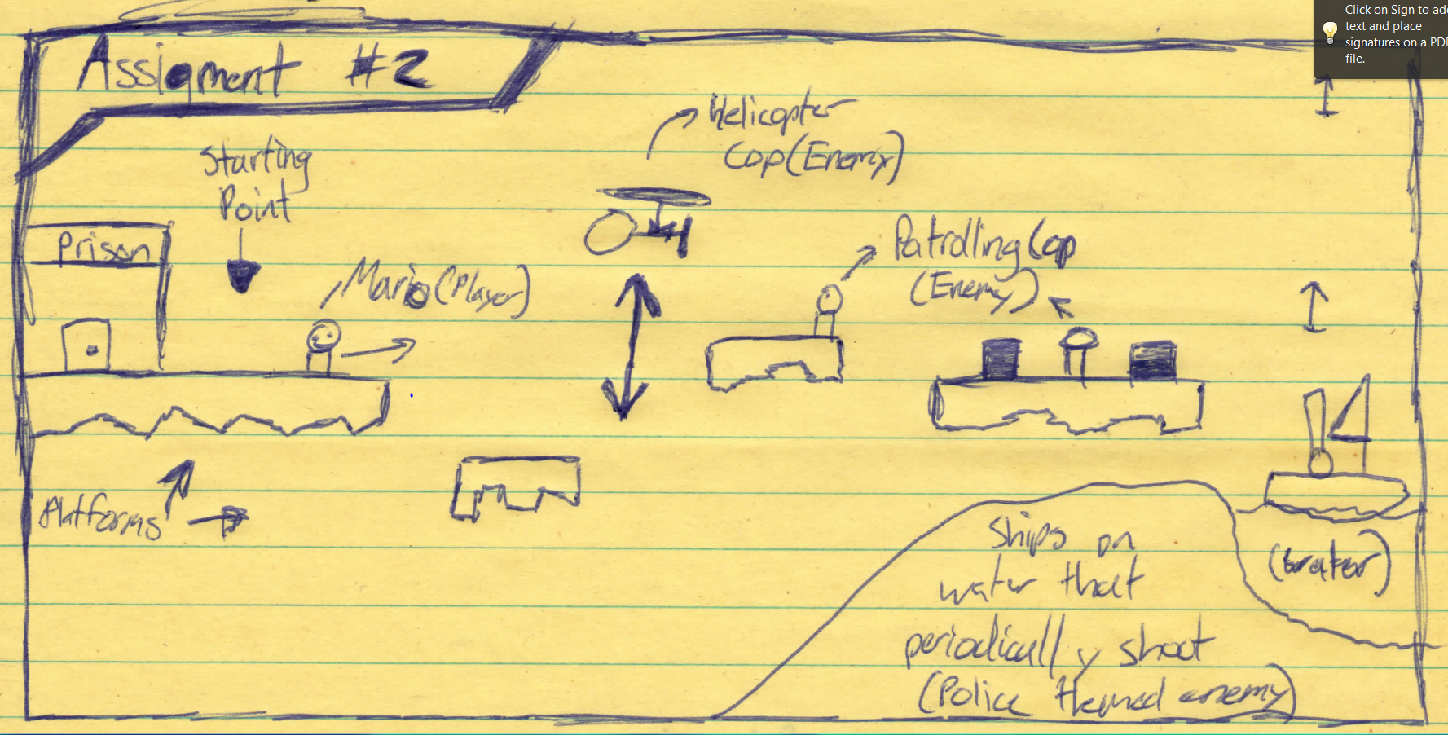

1. **Menu and Screen Descriptions**

*Main Menu:*

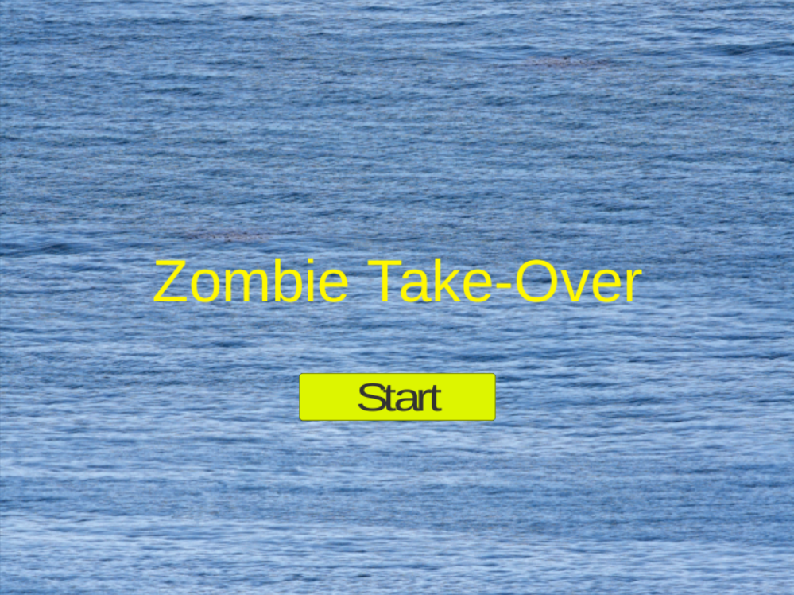

*Main Game Scene:*

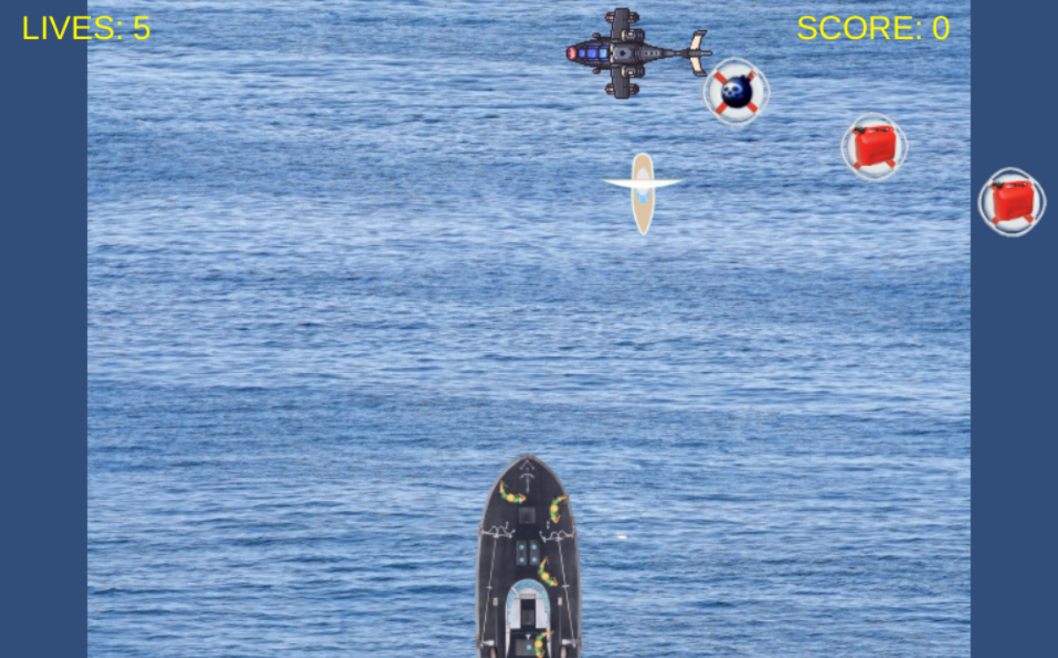

*Game-Over Screen:*

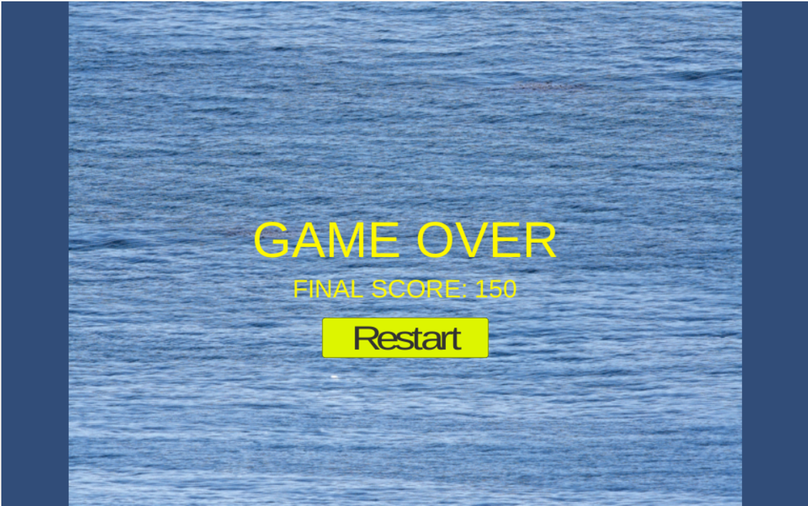

1. **Game World**

*The player navigates their ship through the ocean, dodging explosive buoys dropped by the air force. Explosions activate from hitting other ships and the bombs.*

1. **Levels**

*There is only the main endless level, a main menu screen, and a game-over screen.*

1. **Game Progression**

*The player must hit other ships and collect gas tanks to gain points. The player is aiming to achieve the highest score possible.*

1. **Characters**

*The player ship is a large re-enforced ship, which has several visible zombie humans on board. The zombies have weapons; however, no shooting/bullets were implemented within the game.*

1. **Enemies**

*The enemies are the planes, which carry the both supplies and bombs. The zombie ship can only survive hitting four of the bombs dropped by the plane. After the fifth, it is game over!*

1. **Items**

*The player can collect gas tanks that will increase the player score.*

1. **Vehicles**

*The player can crush or destroy other* ***boats*** *for bonus points.*

1. **Scripts**

*Scripts within the game:*

|  |  |
| --- | --- |
| **Script** | **Description** |
| BoatController | Controls the enemy boats |
| GameController | Controls the HUD |
| ItemsController | Control the movements of the items that are dropped |
| MenuController | Show the main menu, and allow the player to begin the game |
| OceanController | Moves the ocean to provide a scrolling effect |
| PlaneController | Controls the enemy plane and drops items a different locations |
| ShipController | Allow the player to move their ship with the keyboards |

1. **Scoring**

*The player gains points by picking up gas tanks and they can gain points by infecting/destroying other ships, by hitting them.*

1. **Sound Index**

*Sounds within the game:*

|  |  |
| --- | --- |
| **Audio** | **Description** |
| evil | An evil laugh for when the play hits other boats. |
| explosion | An explosion when other ships or bombs are hit. |
| gameover | A gameover voice once all the lives are used. |
| okay | A 'collection' noise when the player hits the gas tanks |

1. **Art / Multimedia Index**

*Art within the game:*

|  |  |
| --- | --- |
| **Artwork** | **Description** |
| boat | small sailboat texture |
| bombb | bomb on a bouy |
| gasb | gas on a bouy |
| mainshipsmall | the player ship with zombies |
| ocean | the ocean scrolling texture |
| plane | the 'air-force' plane |

1. **Future Features**

*I would have liked to implement a ‘health’ bar in this game, so that the player would prefer to avoid other ships. After getting to many bonus points, the zombie ships condition would also diminish. I also initially wanted the boat to run out of gas, but again that can be included in future games that I develop.*